**MTE 203 – Advanced Calculus**

**(Fall 2018)**

**MATLAB Laboratory 2 Worksheet [1]**

Student Name

Yu Qing Shan

Student ID

20648926

# Problem 1

In this Matlab worksheet you will learn how to plot 3D surfaces and the intersection of two 3D surfaces. You will also learn how to construct contour maps.

The equation of the first 3D surface is given by

$$\left(x^{2}+1\right)z^{2}+\cos\left(x^{2}y+1\right)z-\left(2-x^{2}-y^{2}\right)=0 , z>0$$

To plot this 3D surface you will first need to write its equation as a function of the $x$ and $y$ variables.

The 3D surface that will intersected the 3D surface defined above is a plane with equation

$$x=y$$

To plot the curve of intersection between these two 3D surfaces, you will need to find the parametric equation of this curve. Provided that $z$ is always positive, find the answer to the following questions and include them as part of your solution:

1. Write the equation of the surface in the following form
$$z=f\left(x,y\right)=\frac{-\cos\left(x^{2}y+1\right)+\sqrt{\cos^{2}\left(x^{2}y+1\right)+4\left(x^{2}+1\right)\left(2-x^{2}-y^{2}\right)}}{2\left(x^{2}+1\right)}$$

2. Write the parametric equation of the curve of intersection $z=f (x, y)$ and the plane $x=y$ such that both $x$ and $y$ increase when $t$ increases
$$x=t$$

$$y=t$$

$$z=\frac{-\cos\left(t^{3}+1\right)+\sqrt{\cos^{2}\left(t^{3}+1\right)+4\left(t^{2}+1\right)\left(2-{2t}^{2}\right)}}{2\left(t^{2}+1\right)}$$

3. Write a MATLAB program *.m that generates the following plots:
4. Use the Matlab ‘surf’ and ‘meshgrid’ function to plot the 3D surface $z=f(x,y)$ in the rectangular domain $-0.5≤x,y≤0.5$ for the following two fixed increment sizes:

Case 1: $Δx=Δy=0.1$

Case 2: $Δx=Δy=0.05$

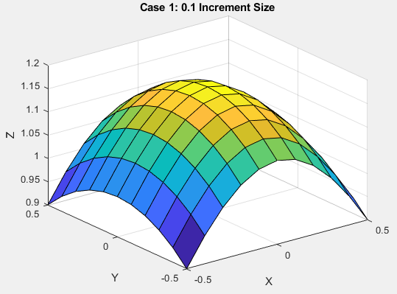

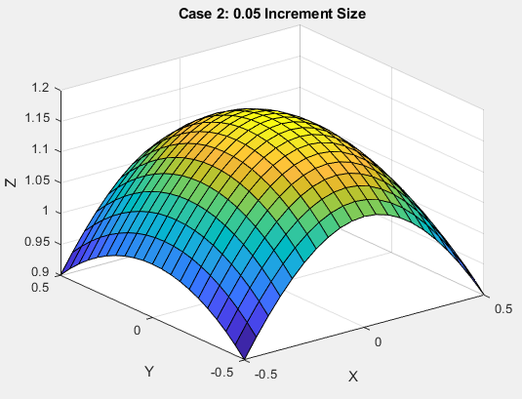

Use the Matlab ‘surfc’ function to add level curves below both of the 3D surfaces plotted in part (a) for $Δx=Δy=0.05$ (case 2). Pick a suitable number of level curves so that the plots don’t look too busy when you label them

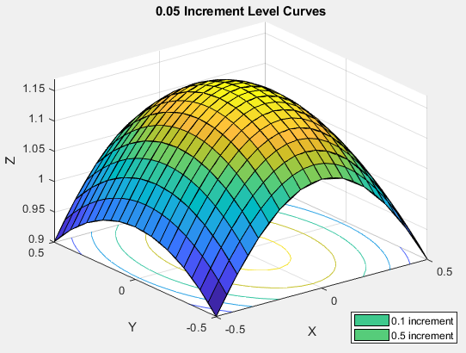

1. Use the Matlab ‘contour’ function to draw the level curves of $z=f(x,y)$ to construct a contour map. Use a total number of 20 level curves in your plot and label each level curve with its corresponding numerical value.

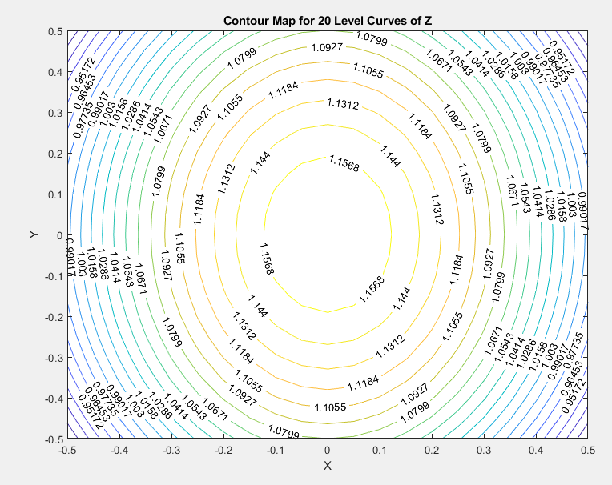

1. Using the Matlab ‘plot3’ function and plot the curve of intersection between the given two surfaces starting at $t=-1$ and ending at $t=1$. To make the figure smoother, sub-divide the domain of $t$ into 1000 equally spaced divisions using the Matlab ‘linspace’ function. To show the intersection curve, use the solid red color as the line type with a line width of 4.

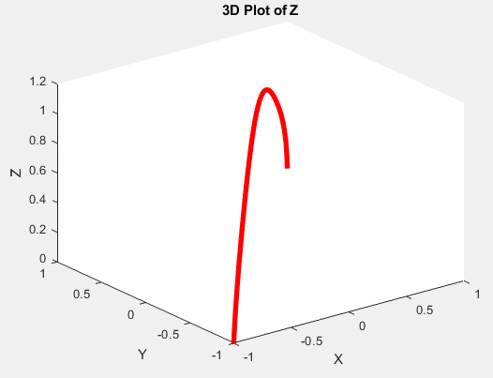

1. Plot the surface, the plane, and the curve of intersection in a single graph.

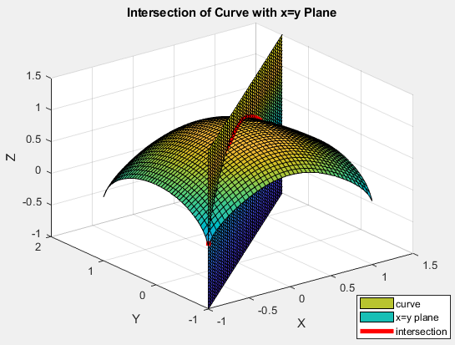

**NOTE:**

**LABEL all the important parts in your graphs clearly indicating the x, y and z-axes.**

**Submission:**

Save all the deliverable files (worksheet and *.m files specified below as one zip file named **“Lastname_Firstname_lab2.zip”**.

To submit the zip file, please use the Lab 2 Dropbox folder in LEARN:

**Course materials/Content/Matlab Laboratories and Projects/Matlab Laboratory 1 – September 13, 2018/Matlab Laboratory 2 – Worksheet Dropbox**

**Deliverables to be included in your “zip” file:**

1. Surf_<Lastname>.m
2. Surfc_<Lastname>.m
3. Contour_<Lastname>.m
4. Plot3_<Lastname>.m
5. MATLAB Worksheet 1 <Lastname>.docx including:
   * Expression for the 3D surface as z=f(x,y)
   * Parametric form (i.e. x(t),y(t),z(t)) of the curve of intersection of the surface and plane
   * 3D surface plot generated with ‘surf’ – both cases
   * Level curves for the surface of case 1 generated with ‘contour’
   * The curve of intersection generated with ‘plot3’
   * The plot showing the 3D surface, the plane and curve of intersection

**IMPORTANT:  
Please note that the dropbox will only accept one file as your submission. Zipping the files will ensure that we get all your related files for grading. Once you click the submission button, any additional files will be treated as a late submission.**

1. Please note that this Laboratory Worksheet must reflect your individual work and that submissions are individual